

VASIREDDY VENKATADRI INSTITUTE OF TECHNOLOGY
Approved by AICTE, Permanently Affiliated to JNTU, Kakinada
Accredited by NAAC with ‘A’ Grade - ISO 9001:2008 Certified
Nambur (V), Peda Kakani (M), Guntur Dt. - 522508 April, 2025.

A Project Report
On
Qline – OPD Management

submitted for partial fulfillment for the award of the degree of

BACHELOR OF TECHNOLOGY

in

Computer Science and Engineering
By

PUTLA DANY ARSHITH - 23BQ1A05I9
PANDEM VASTALYA - 23BQ1A05H5
NALLABOTHULA ANKITHA - 23BQ1A05F4
MITNALA UDAY KIRAN - 23BQ1A05E1

Under the Guidance of
Dr. P. Ravi Kumar
Associate Professor, CSE



CERTIFICATE

This is to certify that the Project Report titled “Qline-OPDmanagement” is being submitted by, Mr. PUTLA DANY ARSHITH, Ms. PANDEM VASTALYA, Ms. NALLABOTHULA ANKITHA, Mr. MITNALA UDAY KIRAN, bearing Registered Numbers 23BQ1A05I9, 23BQ1A05H5, 23BQ1A05F4, and 24BQ5A05E1
respectively of III B.Tech II semester Computer Science & Engineering is a record Bonafide work carried out by them. The results embodied in this report have not been submitted to any other University for the award of any degree.

Project Guide Head of Department
(Dr. P. Ravi Kumar, Associate Professor) (Dr. V. Ramachandran, Professor)

Submitted for Viva-voce Examination held on

Internal Examiner External Examiner

DECLARATION

We, PUTLA DANY ARSHITH, Ms. PANDEM VASTALYA, Ms. NALLABOTHULA ANKITHA, Mr. MITNALA UDAY KIRAN, hereby declare that the Project Report entitled “Deep Learning – Traffic Violation Detection” done by us under the guidance of Dr. P. Ravi Kumar, Associate Professor at Vasireddy Venkatadri Institute of Technology (A) is submitted in partial fulfillment of the requirements for the award of Bachelor of Technology in Computer Science & Engineering. The results embodied in this report have not been submitted to any other university for the award of any degree.

DATE :

PLACE :

SIGNATURE OF THE CANDIDATE(s)

1.

2.

3.

4.

ACKNOWLEGMENT

We take this opportunity to express my deepest gratitude and appreciation to all those people who made this project work easier with words of encouragement, motivation, discipline, and faith by offering different places to look to expand our ideas and helped us towards the successful completion of this project work.
First and foremost, we express our deep gratitude to Sri. Vasireddy Vidya Sagar, Chairman, Vasireddy Venkatadri Institute of Technology (A) for providing necessary facilities throughout the B Tech program.
We express our sincere thanks to Dr. Y. Mallikarjuna Reddy, Principal, Vasireddy Venkatadri Institute of Technology (A) for his constant support and cooperation throughout the B. Tech program.
We express our sincere gratitude to Dr. V. Ramachandran, Professor & HOD, Computer Science & Engineering, Vasireddy Venkatadri Institute of Technology (A) for his constant encouragement, motivation and faith in offering different places to look to expand our ideas.
We would like to express our sincere gratefulness to our Guide Dr. P. Ravi Kumar, Associate Professor, CSE for his insightful advice, motivating suggestions, invaluable guidance, help and support in the successful completion of this project.
We would like to express our sincere heartfelt thanks to our Project Coordinator Dr. Vidya Sagar Uppuluri, Professor, CSE for his valuable advices, motivating suggestions, moral support, help and coordination among us in successful completion of this project.
We would like to take this opportunity to express our thanks to all the Teaching and Non-Teaching Staff in the Department of Computer Science & Engineering, VVIT for their invaluable help and support.

Names of Students
PUTLA DANY ARSHITH 23BQ1A05I9
PANDEM VASTALYA 23BQ1A05H5
NALLABOTHULA ANKITHA 23BQ1A05F4
MITNALA UDAY KIRAN 23BQ1A05E1



INSTITUTE VISSION

To impart quality education through exploration and experimentation and generate socially conscious engineers, embedding ethics and values, for the advancement in Science and Technology.

INSTITUTE MISSION

- To educate students with practical approach to dovetail them to industry needs.
- To govern the institution with a proactive and professional management with passionate teaching faculty.
- To provide holistic and integrated education and achieve over all development of students imparting scientific and technical, social and cognitive, managerial and organizational skills.
- To compete with the best and be the most preferred institution of the studious and the scholarly.
- To forge strong relationships and linkage with the industry.



DEPARTMENT VISSION

Providing quality education to enable the generation of socially conscious software engineers who can contribute to the advancement in the field of computer science and engineering.

DEPARTMENT MISSION

- To equip the graduates with the knowledge and skills required to enable them to be industry ready.

- To train socially responsible, disciplined engineers who work with good leadership skills and can contribute for nation building.

- To make our graduates proficient in cutting edge technologies through student centric teaching- learning process and empower them to contribute significantly to the software industry.

- To shape the department into a centre of academic and research excellence.





PEO1 | To provide the graduates with solid foundation in computer science and engineering along with fundamentals of Mathematics and Sciences with a view to impart in them high quality technical skills like modelling, analyzing, designing, programming and implementation with global competence and helps the graduates for life-long learning.
PEO2 | To prepare and motivate graduates with recent technological developments related to core subjects like programming, databases, design of compilers and Network Security aspects and future technologies so as to contribute effectively for Research & Development by participating in professional activities like publishing and seeking copy rights.
PEO3 | To train graduates to choose a decent career option either in high degree of employability / Entrepreneur or, in higher education by empowering students with ethical administrative acumen, ability to handle critical situations and training to excel in competitive examinations.
PEO4 | To train the graduates to have basic interpersonal skills and sense of social responsibility that paves them a way to become good team members and leaders.



The B.Tech CSE program has documented measurable outcomes that are based on the needs of the program’s stakeholders. The program outcomes, which are derived from ABET criteria, were first drafted in the academic year 2009–10 and later revised in 2010–11. The program outcomes that the department presently adopts are as follows:

1 | Engineering knowledge | Apply the knowledge of mathematics, science, engineering fundamentals and an engineering specialization to the solution of complex engineering problems.
2 | Problem analysis | Identify, formulate, review research literature, and analyze complex engineering problems reaching substantiated conclusions using first principles of mathematics, natural science and engineering sciences.
3 | Design/development of solutions | Design solutions for complex engineering problems and design system components or processes that meet the specified needs with appropriate consideration for the public health and safety, and the cultural, societal and environmental considerations.
4 | Conduct investigations of complex problems | Use research based knowledge and research methods including design of experiments, analysis and interpretation of data, and synthesis of the information to provide valid conclusions.
5 | Modern tool usage | Create, select and apply appropriate techniques, resources and modern engineering and IT tools including prediction and modeling to complex engineering activities with an understanding of the limitations.



6 | The Engineer and Society | Apply reasoning informed by the contextual knowledge to assess societal, health, safety, legal and cultural issues and the consequent responsibilities relevant to the professional engineering practice.
7 | Environment and Sustainability | Understand the impact of the professional engineering solutions in the societal and environmental contexts, and demonstrate the knowledge of, and need for sustainable development.
8 | Ethics | Apply ethical principles and commit to professional ethics and responsibilities and norms of the engineering practice.
9 | Individual and Team Work | Function effectively as an individual and as a member or leader in diverse teams, and in multidisciplinary settings.
10 | Communication | Communicate effectively on complex engineering activities with the engineering community and with society at large, such as being able to comprehend and write effective reports and design documentation, make effective presentations, and give and receive clear instructions.
11 | Project Management and Finance | Demonstrate knowledge and understanding of the engineering and management principles and apply these to one’s own work, as a member and leader in a team, to manage projects and in multidisciplinary environments.
12 | Lifelong Learning | Recognize the need for, and have the preparation and ability to engage in independent and lifelong learning in the broadest context of technological change.



 |  | 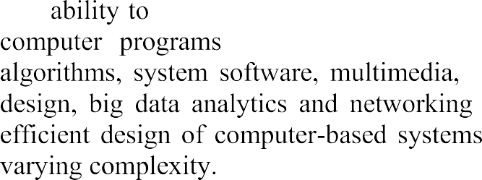
 |  | 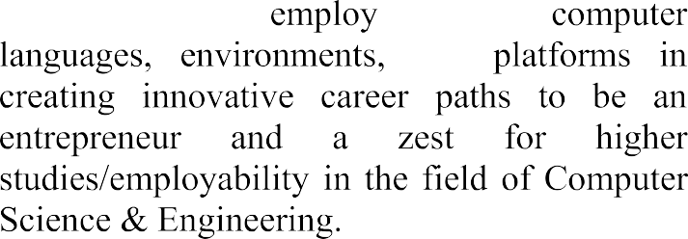







 | PO1 | PO2 | PO3 | PO4 | PO5 | PO6 | PO7 | PO8 | PO9 | PO10 | PO11 | PO12 | PSO1 | PSO2
CO1 | 1 | 2 | 1 |  |  | 2 | 2 | 3 |  | 2 |  |  | 1
CO2 | 2 | 2 | 3 | 2 | 2 |  | 2 | 1 | 2 | 2 | 2 | 1 | 3 | 1
CO3 |  | 1 | 1 | 1 | 3 |  |  |  |  |  |  | 1 | 1
CO4 | 1 |  |  |  |  |  |  |  | 3 | 3 |  |  | 1 | 1
CO5 |  | 1 |  |  |  |  |  | 2 | 3 | 3 | 2 |  | 1 | 2

INDEX

CH No | TITLE | PAGE NO
CHAPTER 1 | INTRODUCTION | 1–2
 | 1.1 Introduction | 1–2
CHAPTER 2 | AIM AND SCOPE | 3–4
 | 2.1 Existing System | 3
 | 2.2 Proposed System | 4
CHAPTER 3 | CONCEPT AND METHODS | 5-9
 | 3.1 Problem Description | 5
 | 3.2 Proposed Solution | 5
 | 3.2.1 Dataset | 6
 | 3.2.2 Data Preparation | 7
 | 3.2.3 Data Preprocessing | 7
 | 3.2.4 Data Augmentation | 8
 | 3.2.5 System Models/Working Mechanism | 8
 | 3.2.6 Performance Metrics | 9
CHAPTER 4 | IMPLEMENTATION | 10-16
 | 4.1 Tools Used | 10
 | 4.2 Code | 11
 | 4.3 Results and Screenshots | 14
CHAPTER 5 | CONCLUSION AND FUTURE SCOPE | 17-19
 | REFERENCES | 20
 | APPENDIX
 | Conference Publication Certificate(s)
 | Published Article in the Journal / Proceedings

CHAPTER – 1

INTRODUCTION
In the present healthcare environment, hospitals are required to manage a large number of patients efficiently, especially in the Outpatient Department (OPD). The OPD is one of the most important sections of a hospital, where patients consult doctors for diagnosis and treatment without being admitted. However, in many hospitals, OPD management is still carried out using traditional manual methods. This leads to several issues such as long waiting times, overcrowding, confusion among patients, and inefficient utilization of medical resources.
Patients visiting hospitals often have to stand in long queues to obtain tokens and wait for their turn without knowing the exact consultation time. This lack of real-time information creates uncertainty and dissatisfaction among patients. In many cases, patients may spend several hours waiting, even for a short consultation. This not only affects patient experience but also reduces the overall efficiency of hospital services.
On the other hand, doctors face challenges in managing their daily schedules due to unstructured patient flow. Without a proper system, it becomes difficult to maintain a fixed consultation time per patient. Unexpected delays, emergency cases, and manual scheduling further complicate the process. As a result, the workload on doctors increases, and it becomes difficult to provide quality healthcare services.
Another major issue is the absence of a centralized system to monitor OPD queues. Patients do not have access to real-time updates about their position in the queue, and hospital staff must manually manage patient flow. This leads to miscommunication, delays, and inefficient handling of appointments. Additionally, hospitals lack proper data management systems to store and analyze patient and appointment information.
To overcome these challenges, this project proposes Qline – OPD Queue and Appointment Management System, a web-based application designed to digitize and streamline OPD operations. The system provides an efficient way to manage patient appointments, track queues in real time, and improve overall hospital workflow.
In this system, patients can book appointments online by selecting a doctor, date, and available time slot. After booking, they can view their position in the queue and receive real-time updates regarding their turn. This reduces unnecessary waiting time and improves patient convenience. Doctors can manage their schedules, control consultation time, and handle delays effectively. The system also allows administrators to monitor hospital operations and manage doctors and appointments efficiently.
The proposed system is developed using modern web technologies such as Next.js for frontend development, Node.js and Express.js for backend processing, MongoDB for data storage, and Socket.IO for real-time communication. These technologies ensure that the system is fast, scalable, and capable of handling multiple users simultaneously.
Overall, the Qline system provides a digital solution to improve OPD management by reducing waiting time, increasing transparency, and enhancing patient satisfaction. It helps hospitals deliver better healthcare services while making the process more organized and efficient.

CHAPTER – 2

AIM AND SCOPE
2.1 EXISTING SYSTEM
Currently, most hospitals manage OPD queues manually, which leads to several inefficiencies in handling patient flow. Patients are required to visit the hospital physically, obtain a token, and wait for their turn without knowing the exact waiting time. This process results in long queues, overcrowding, and confusion among patients.
Manual systems do not provide real-time information about queue status. Patients are unaware of how many people are ahead of them or how long they need to wait. This lack of transparency creates frustration and dissatisfaction. In addition, patients often arrive early and spend unnecessary time waiting in hospitals.
Doctors also face difficulties in managing their schedules effectively. Since patient flow is not properly organized, doctors may experience uneven workloads. Some time slots may be overcrowded, while others may remain underutilized. This leads to inefficient use of time and resources.
Another limitation of the existing system is the absence of digital record management. Patient details, appointment data, and queue information are often handled manually, which increases the chances of errors and data loss. It also becomes difficult for hospital administrators to analyze patient flow and improve system performance.
There is also no proper communication system to notify patients about delays or schedule changes. As a result, patients remain unaware of updates and continue waiting unnecessarily.
Due to these limitations, the existing system is inefficient, time-consuming, and unable to meet the growing demands of modern healthcare services.

2.2 PROPOSED SYSTEM
To overcome the limitations of the existing system, the proposed solution is Qline – a Web-Based OPD Queue and Appointment Management System. This system provides a digital platform that simplifies appointment booking and queue management.
In the proposed system, patients can book appointments online by selecting a doctor, date, and available time slot. The system automatically generates time slots based on the doctor’s schedule, ensuring proper distribution of patients throughout the day.
One of the key features of the system is real-time queue tracking. Patients can view their current position in the queue and get an estimated waiting time. This helps them plan their visit accordingly and reduces unnecessary waiting.
Doctors can manage their schedules by setting consultation time, adding breaks, and controlling the number of patients per day. The system also allows doctors to handle delays by adjusting upcoming appointments dynamically.
The system includes a notification feature that informs patients about appointment confirmation, delays, and their upcoming turn. This improves communication and reduces confusion.
Administrators can monitor hospital operations, manage doctors, and analyze patient flow using the system. The digital approach ensures better data management, improved efficiency, and enhanced patient experience.
Overall, the proposed system provides a modern, efficient, and user-friendly solution for OPD management.

CHAPTER – 3

CONCEPTS AND METHODS
3.1 PROBLEM DESCRIPTION
In the current healthcare system, hospitals face significant challenges in managing OPD (Outpatient Department) queues efficiently. Most hospitals still rely on manual processes for handling patient appointments and queue management. This traditional approach leads to several problems such as long waiting times, overcrowding, lack of transparency, and inefficient use of resources.
Patients visiting hospitals often have to wait for extended periods without knowing their exact position in the queue. This creates uncertainty and dissatisfaction. In many cases, patients arrive early and spend unnecessary time waiting, even when their consultation is scheduled later. This results in overcrowded waiting areas and discomfort for patients.
Another major issue is the absence of real-time queue monitoring. Patients do not have access to live updates regarding their turn, which makes it difficult for them to plan their visit effectively. Additionally, there is no proper system to notify patients about delays or changes in schedule.
Doctors also face challenges due to unstructured patient flow. Without a proper scheduling system, it becomes difficult to manage consultation time efficiently. Unexpected delays, emergency cases, and uneven distribution of appointments increase the workload on doctors and affect the quality of healthcare services.
Hospital administrators also lack a centralized system to monitor OPD activities. Managing patient records, appointments, and queue status manually increases the chances of errors and inefficiencies. It also becomes difficult to analyze patient flow and optimize hospital operations.
Therefore, the main problem addressed in this project is the lack of a digital system that can efficiently manage OPD queues, provide real-time updates, and improve coordination between patients, doctors, and administrators.

3.2 PROPOSED SOLUTION
To solve the problems identified in the existing system, the proposed solution is Qline – OPD Queue and Appointment Management System, a web-based application designed to digitize and optimize hospital OPD operations.
The system provides a centralized platform where patients can book appointments online, select doctors, choose available time slots, and track their queue position in real time. This eliminates the need for physical waiting and reduces overcrowding in hospitals.
The system automatically generates time slots based on the doctor’s schedule, consultation duration, and break periods. This ensures proper distribution of patients throughout the day and prevents overbooking.
One of the key features of the system is real-time queue tracking using technologies such as Socket.IO. Patients can view their current position in the queue, the number of patients ahead of them, and estimated waiting time. This helps them plan their visit accordingly.
Doctors can manage their schedules by setting working hours, consultation time, and maximum number of patients per day. They can also handle delays by extending consultation time or adding breaks, and the system automatically updates the queue.
Administrators can manage doctors, monitor daily operations, and analyze patient flow. The system also provides notifications to patients regarding booking confirmation, delays, and upcoming turns.
By integrating all these features, the proposed system provides an efficient, transparent, and user-friendly solution for OPD management.

3.2.1 DATASET (DATABASE DESIGN)
In this project, instead of using a traditional dataset, a structured database is used to store and manage all system data. The database plays a crucial role in maintaining patient records, appointment details, doctor schedules, and queue information.
The system uses MongoDB as the database due to its flexibility and ability to handle dynamic data structures.
The main components of the database include:
1. User Data
This includes information about all users in the system such as patients, doctors, and administrators. The data stored includes:
- User ID
- Name
- Email
- Password
- Role (Patient, Doctor, Admin)
2. Doctor Data
This dataset contains details about doctors such as:
- Doctor ID
- Department
- Consultation time
- Working hours
- Break timings
- Maximum patients per day
3. Appointment Data
This includes all appointment-related information:
- Appointment ID
- Patient ID
- Doctor ID
- Date and time
- Slot details
- Status (Booked, Completed, Cancelled)
4. Queue Data
This dataset manages real-time queue information:
- Current token
- Waiting list
- Queue status
The database structure ensures efficient storage, retrieval, and management of system data.

3.2.2 DATA PREPARATION
Data preparation is an important step to ensure that the system works efficiently and accurately. In this project, data is collected from user inputs such as registration forms, appointment booking details, and doctor schedules.
The following steps are involved in data preparation:
Data Collection
Information is collected from patients and doctors during registration and booking processes.
Data Structuring
The collected data is organized into structured formats such as database collections. Each type of data is stored in separate collections for better management.
Data Validation
Input data is validated to ensure correctness. For example:
- Email format validation
- Required fields check
- Time slot validation
Data Storage
The validated data is stored securely in the database for further processing.
Proper data preparation ensures accuracy and reliability of the system.

3.2.3 DATA PREPROCESSING
Data preprocessing involves processing the stored data to make it ready for system operations such as appointment booking and queue management.
The system performs the following preprocessing tasks:
Input Validation
Ensures that all user inputs are correct and complete before processing.
Duplicate Removal
Prevents duplicate bookings for the same time slot.
Time Formatting
Standardizes date and time formats for consistency.
Queue Initialization
Initializes queue data when a new appointment schedule is created.
These preprocessing steps ensure smooth functioning of the system.

3.2.4 DATA AUGMENTATION (SYSTEM ENHANCEMENT)
In this project, data augmentation refers to enhancing system functionality by dynamically updating and managing data.
This includes:
- Dynamic generation of time slots based on doctor schedules
- Real-time updating of queue status
- Automatic adjustment of schedule during delays
- Continuous updating of appointment status
These enhancements improve system efficiency and provide better user experience.

3.2.5 SYSTEM MODELS / WORKING MECHANISM
The working mechanism of the Qline system follows a structured process:
1. User Registration and Login
Users create accounts and log in securely.
2. Appointment Booking
Patients select doctor, date, and time slot to book appointments.
3. Slot Generation
The system generates slots based on doctor schedule.
4. Queue Management
Patients are assigned tokens and added to the queue.
5. Real-Time Updates
Queue status is updated using Socket.IO.
6. Consultation Handling
Doctors call patients, complete consultations, or extend time.
7. Notification System
Patients receive updates about their appointment and queue status.
This workflow ensures efficient operation of the system.

3.2.6 PERFORMANCE METRICS
The performance of the system is evaluated using the following metrics:
Waiting Time Reduction
Measures how effectively the system reduces patient waiting time.
System Response Time
Measures how quickly the system responds to user actions.
Slot Utilization
Evaluates how efficiently appointment slots are used.
User Satisfaction
Measures patient and doctor satisfaction with the system.
System Reliability
Ensures consistent and error-free operation.
These metrics help in evaluating the effectiveness of the system.

CHAPTER – 4

IMPLEMENTATION
4.1 TOOLS USED
The development of the Qline – OPD Queue and Appointment Management System requires a combination of modern technologies and tools to ensure efficient performance, scalability, and real-time functionality. These tools help in designing the user interface, processing user requests, managing data, and enabling communication between different components of the system.
1. Programming Language – JavaScript
JavaScript is the primary programming language used in this project. It is used in both frontend and backend development. JavaScript helps in implementing system logic, handling user interactions, processing data, and managing communication between different modules of the system.
2. Frontend Technologies
Next.js (React Framework)
Next.js is used to build the frontend of the application. It provides a component-based architecture that helps in developing reusable UI components. It also supports fast rendering and efficient routing, which improves the performance of the application.
Tailwind CSS
Tailwind CSS is used for designing the user interface. It helps in creating a clean, responsive, and visually appealing design. It also ensures consistency in styling across all pages of the application.
JavaScript (Client-side)
Client-side JavaScript is used to handle user interactions such as form submissions, button clicks, and dynamic updates of data on the screen.

3. Backend Technologies
Node.js
Node.js is used as the runtime environment for backend development. It allows handling multiple user requests efficiently and supports real-time operations.
Express.js
Express.js is used to build the backend server and APIs. It handles routing, request processing, and communication between frontend and database.

4. Database
MongoDB
MongoDB is used as the database for storing all system data such as user details, doctor information, appointments, and queue data. It provides flexibility in handling structured and unstructured data and supports fast data retrieval.

5. Real-Time Communication
Socket.IO
Socket.IO is used to enable real-time communication between the server and clients. It helps in updating queue status instantly when there are changes such as consultation completion or delay.

6. Authentication and Security
JWT (JSON Web Tokens)
JWT is used for secure authentication of users. It ensures that only authorized users can access the system.
bcrypt
bcrypt is used for encrypting user passwords before storing them in the database.

7. Development Tools
Visual Studio Code
VS Code is used as the development environment for writing and testing code.
Postman
Postman is used for testing APIs and verifying backend functionality.
Git and GitHub
Git is used for version control, and GitHub is used for storing and managing project code.

8. Web Browsers
Browsers such as Google Chrome and Microsoft Edge are used for testing and running the application.

4.2 CODE STRUCTURE
The Qline system is designed using a modular architecture, where different functionalities are divided into separate modules. This approach improves system maintainability, scalability, and readability.

1. User Authentication Module
This module handles user registration, login, and authentication. It verifies user credentials and provides secure access to the system. Role-based access control is implemented to differentiate between patients, doctors, and administrators.

2. Patient Module
This module allows patients to:
- Register and manage profiles
- Book appointments
- View queue status
- Track appointment history

3. Doctor Module
This module allows doctors to:
- Set working hours
- Define consultation time
- Manage appointments
- Handle delays and breaks

4. Appointment Module
This module manages:
- Slot generation
- Appointment booking
- Appointment status updates
It ensures that appointments are scheduled efficiently without conflicts.

5. Queue Management Module
This is the core module of the system. It:
- Assigns tokens to patients
- Maintains queue order (FIFO)
- Updates queue in real time
- Calculates waiting time

6. Notification Module
This module sends notifications to users regarding:
- Booking confirmation
- Delay updates
- Upcoming turn alerts

7. Admin Module
This module allows administrators to:
- Manage doctors
- Monitor queues
- Analyze system performance

8. Database Interaction Layer
This layer handles communication between the backend and MongoDB database. It performs operations such as data insertion, retrieval, updating, and deletion.

4.3 RESULTS AND OUTPUT SCREENSHOTS
After implementing the system, the Qline application successfully performs all required functionalities.
  - User Registration and Login
Users can create accounts and log in securely using authentication mechanisms.
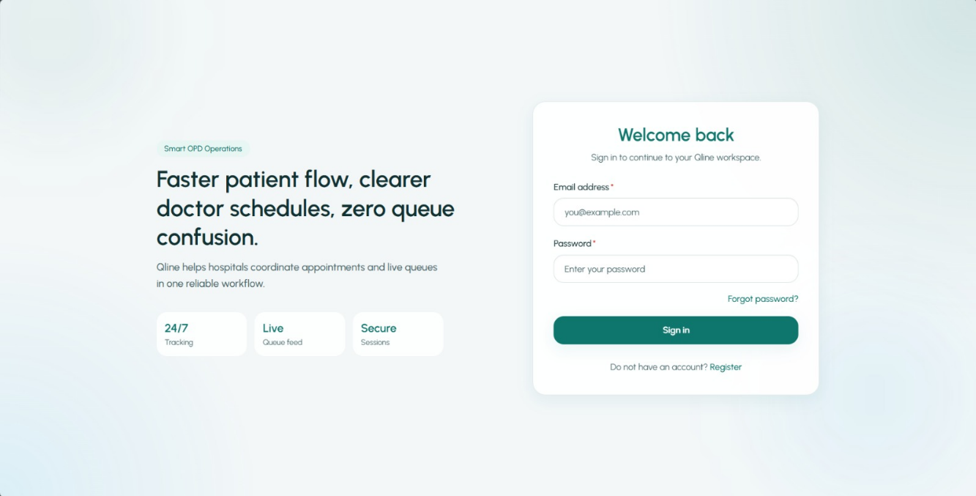

  - Appointment Booking
Patients can select doctors, choose available slots, and book appointments easily.
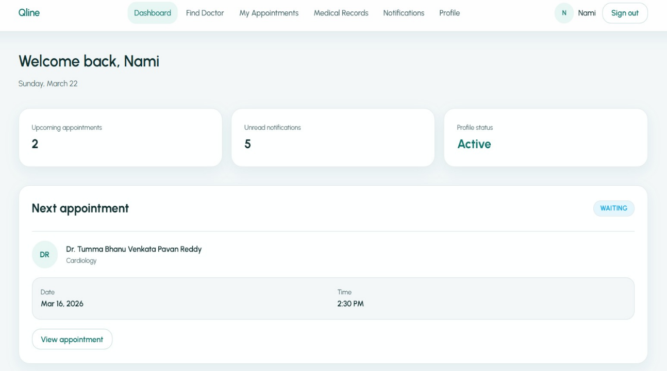

  - Real-Time Queue Tracking
Patients can view their position in the queue and receive updates instantly.
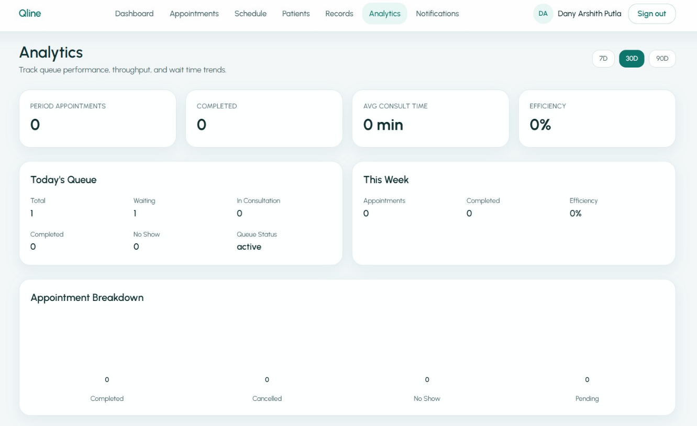

  - Doctor Schedule Management
Doctors can manage schedules, consultation time, and handle delays.
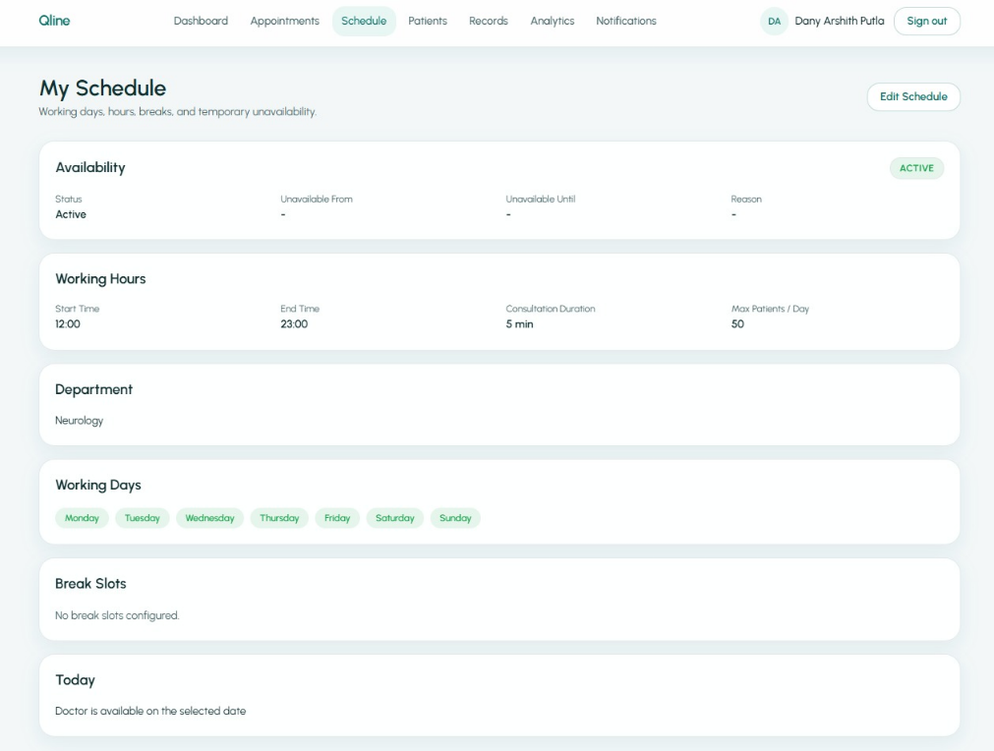

  - Notification System
Patients receive notifications about appointment status and queue updates.
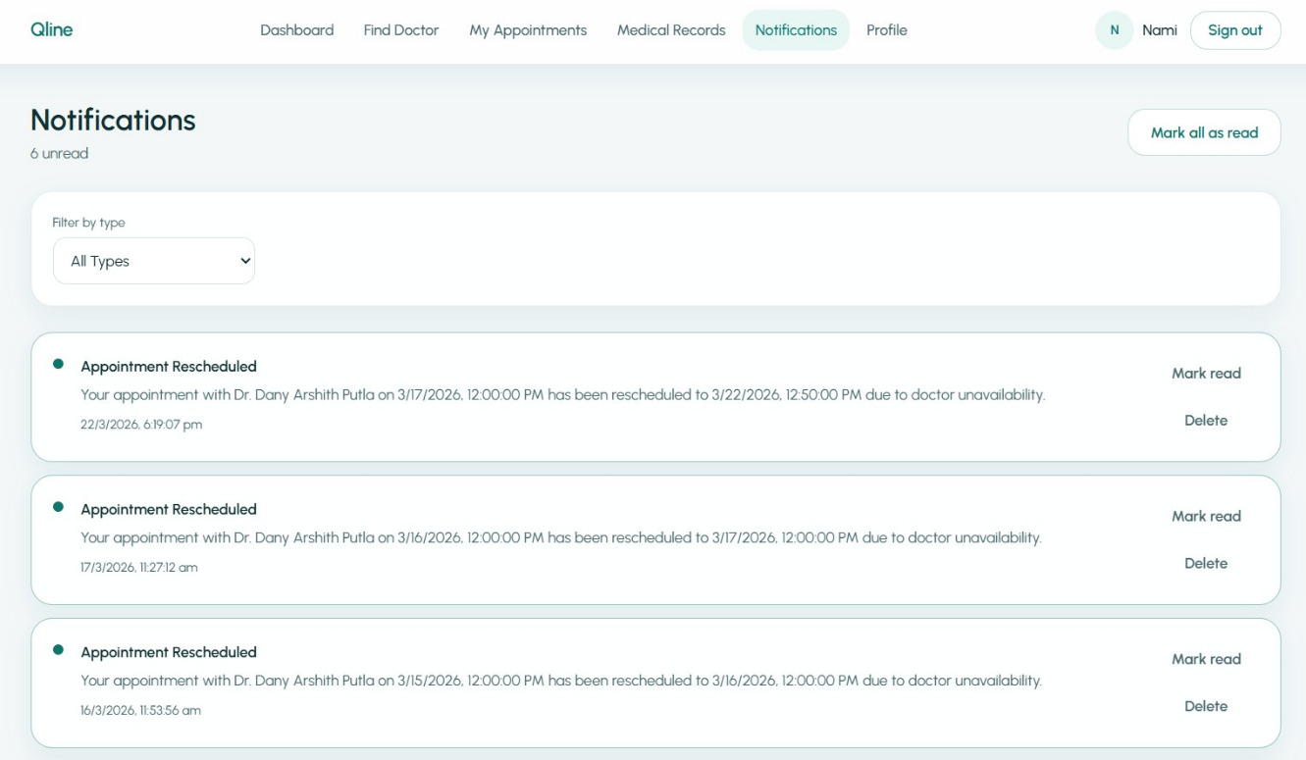

  - Improved Efficiency
The system reduces waiting time and improves hospital workflow.
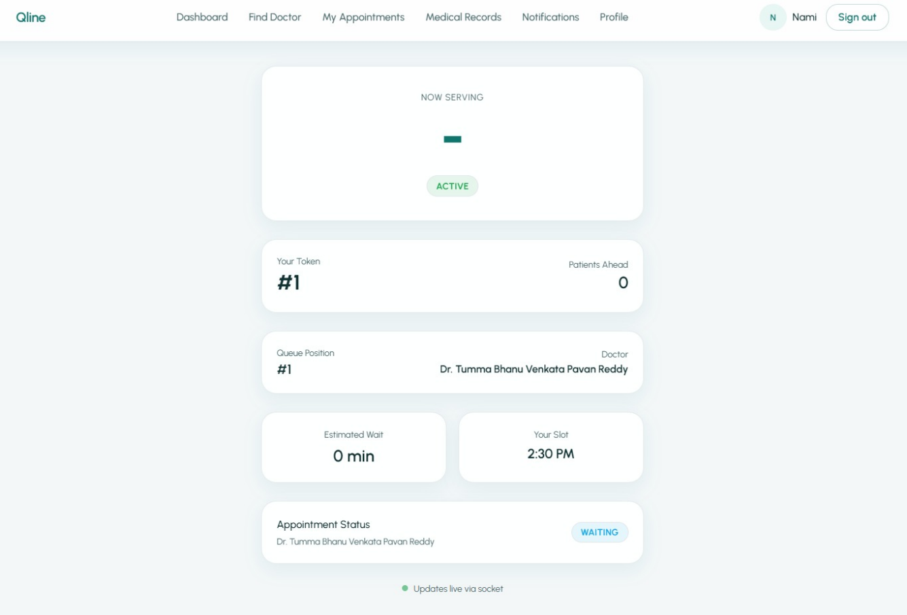

CHAPTER – 5

CONCLUSION AND SCOPE
CONCLUSION
The Qline – OPD Queue and Appointment Management System is designed to address the major challenges faced in traditional hospital OPD management. In many hospitals, patient queues are handled manually, which leads to long waiting times, overcrowding, lack of transparency, and inefficient use of resources. This system provides a digital solution to overcome these issues by introducing an organized and automated approach to appointment booking and queue management.
The system allows patients to book appointments online by selecting doctors, dates, and available time slots. This reduces the need for physical presence in hospitals and minimizes unnecessary waiting. Patients can also track their position in the queue in real time, which improves transparency and helps them plan their visit more effectively.
One of the key advantages of the system is real-time queue management. Using modern technologies, the system continuously updates the queue based on doctor actions such as consultation completion or delay. This ensures that patients receive accurate and up-to-date information about their turn. As a result, patient satisfaction is significantly improved.
The system also provides useful features for doctors, allowing them to manage their schedules efficiently. Doctors can define consultation time, set working hours, add breaks, and handle delays dynamically. This helps in maintaining a structured workflow and reduces workload stress.
For hospital administrators, the system offers better control and monitoring capabilities. Administrators can manage doctor profiles, monitor patient flow, and analyze system performance. The digital storage of data also improves record management and reduces the chances of errors.
The use of modern technologies such as Next.js, Node.js, MongoDB, and Socket.IO ensures that the system is scalable, efficient, and capable of handling real-time operations. The modular architecture of the system makes it easy to maintain and extend in the future.
Overall, the Qline system successfully provides an efficient, transparent, and user-friendly solution for OPD management. It reduces waiting time, improves operational efficiency, enhances patient experience, and supports better healthcare service delivery.

FUTURE SCOPE
Although the Qline system provides a complete solution for OPD queue and appointment management, there are several opportunities to enhance the system further in the future.
One important improvement is the development of a mobile application. A mobile app would allow patients to book appointments, track queue status, and receive notifications directly on their smartphones. This would improve accessibility and user convenience.
Another enhancement is the integration of Artificial Intelligence (AI) for predicting waiting time. AI algorithms can analyze historical data and provide more accurate estimates of waiting time. This would help patients plan their visits more efficiently and reduce uncertainty.
The system can also be extended to support online consultation (telemedicine). This feature would allow patients to consult doctors remotely through video calls, which is especially useful for patients who cannot visit hospitals physically.
Integration with Electronic Medical Records (EMR) systems is another important improvement. This would allow doctors to access patient history, prescriptions, and medical reports directly within the system, improving the quality of healthcare services.
The addition of a payment gateway can also enhance the system by enabling online payment for consultations. This would make the process more convenient and reduce the need for manual payment handling in hospitals.
Another future enhancement is the use of SMS and push notifications to keep patients informed about appointment status, delays, and reminders. This improves communication and ensures that patients do not miss their appointments.
The system can also be expanded to support multi-hospital deployment, where multiple hospitals can use the same platform. This would make the system more scalable and suitable for large healthcare networks.
Further improvements may include advanced analytics and reporting features, which can help hospitals analyze patient flow, doctor performance, and system efficiency.
With these enhancements, the Qline system can evolve into a comprehensive healthcare management platform that provides intelligent, efficient, and patient-friendly services.

ABSTRACT
Problem Statement: In many hospitals, OPD queues are managed manually, which leads to long and uncertain waiting times, overcrowding, and confusion among patients. The absence of a digital system to track OPD queues in real time results in inefficient patient flow and underutilization of hospital resources.
Description: In many hospitals, OPD patient queues are managed manually, leading to long and unpredictable waiting times. Patients lack real-time information about their position in the queue, which results in overcrowding and confusion in OPD areas. The absence of an automated queue management system also affects doctors’ efficiency and overall patient flow. Therefore, there is a need for a digital OPD queue management system to improve transparency, reduce waiting time, and enhance OPD operations.
Objectives:
- Digitize the OPD patient registration process
- Automatically generate and manage OPD tokens
- Maintain a First-In-First-Out (FIFO) queue system
- Display real-time OPD queue status to patients
- Estimate and show patient waiting time
- Improve efficiency and reduce overcrowding in OPD services

REFERENCES
Qline – OPD Queue and Appointment Management System, GitHub Repository. Avaihttps:
//github.com/DanyArshith/Qline_OPDmanagementlable:

